|  |  |
| --- | --- |
| ELECTRIC VEHICLES MARKET  Types of Electric Vehicles: Principles, Benefits and Manufacturing - APW  Programming Language: Phyton |  |

**📝 PROJECT SUMMARY:**

Electric vehicles are automobiles that are powered by one or more electric motors, using energy stored in rechargeable batteries. In this project, I analyzed a large dataset containing information about electric vehicles from 1997 to 2025, including their models, manufacturers, electric range, eligibility for clean fuel programs, and utility providers. The goal was to extract meaningful insights, visualize trends, and identify patterns in EV adoption.

**🎯DATASET:**

I downloaded the dataset from Kaggle.

Here is the link: <https://www.kaggle.com/datasets/rajkumarpandey02/electric-vehicle-population-data>

**Columns informations:**

* VIN (1-10): The first 10 characters of each vehicle's Vehicle Identification Number (VIN)
* County: The county where the vehicle is registered
* City: The city where the vehicle is registered
* State: The state where the vehicle is registered
* Postal Code: The postal code of the vehicle registration location
* Model Year: The year the vehicle was manufactured
* Make: The manufacturer or brand of the vehicle
* Model: The specific model of the vehicle
* Electric Vehicle Type: Indicates whether the vehicle is a Battery Electric Vehicle (BEV) or a Plug-in Hybrid Electric Vehicle (PHEV).
* Clean Alternative Fuel Vehicle (CAFV) Eligibility: Indicates if the vehicle is eligible for Clean Alternative Fuel Vehicle benefits.
* Electric Range: Describes how far a vehicle can travel purely on its electric charge
* Base MSRP: The lowest manufacturer's suggested retail price for the vehicle
* Legislative District: The legislative district associated with the vehicle registration location
* DOL Vehicle ID: Unique identifier assigned by the Washington State Department of Licensing
* Vehicle Location: The precise location of the vehicle
* Electric Utility: The electric utility company associated with the vehicle
* 2020 Census Tract: The census tract identifier is a combination of the state, county, and census tract codes as assigned by the United States Census Bureau in the 2020 census, also known as Geographic Identifier (GEOID) where the vehicle is registered

🔹 STEPS AND ANALYSIS:

1. Import the libraries

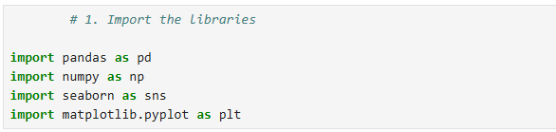

1. Load the dataset into Python program



1. Inspect the data 🔍

* The base informations about the dataframe

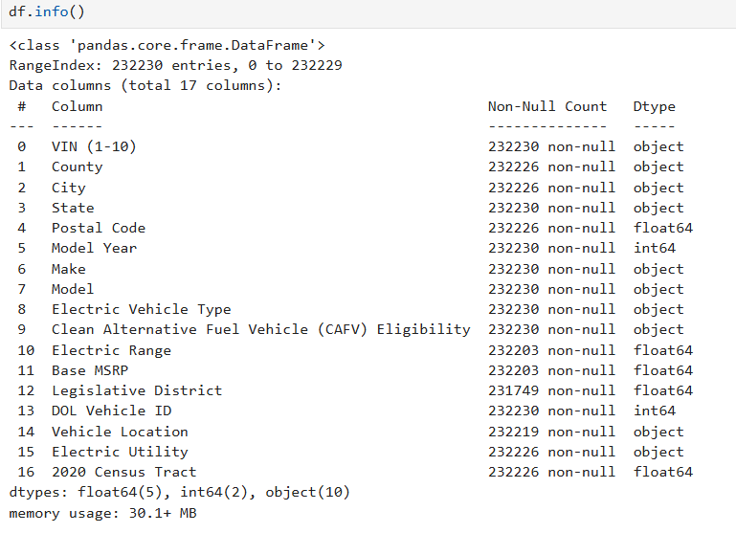

* Display the first 5 rows of the spreadsheet

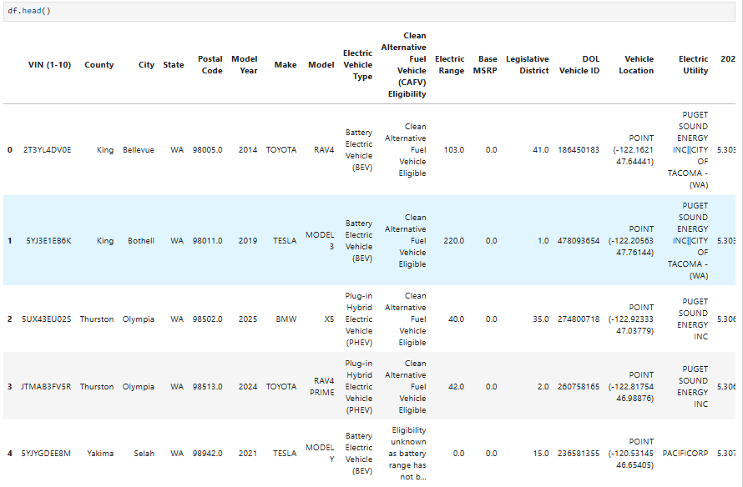

1. Data Cleaning and Preprocesing 🛠

* Remove some columns that are not important for study

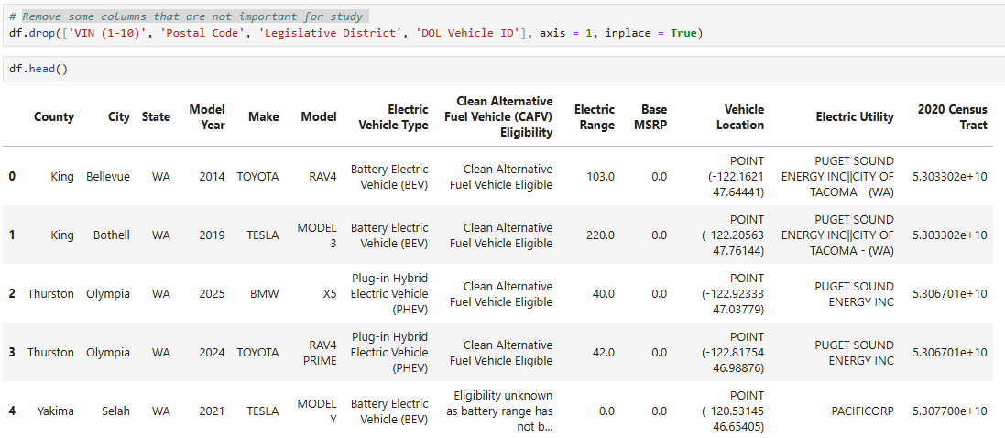

* Handling Missing Values

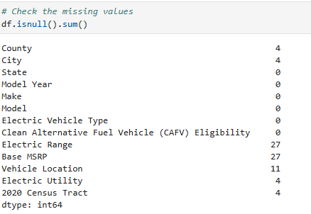

In our dataset, we notice that only a small number of rows have missing values in certain columns compared to the total number of non-null values, so we can safely drop these rows to allow us to work with a clean dataset.

* Create a new column ”Location” for a more informative and combined

representation of geographical attributes

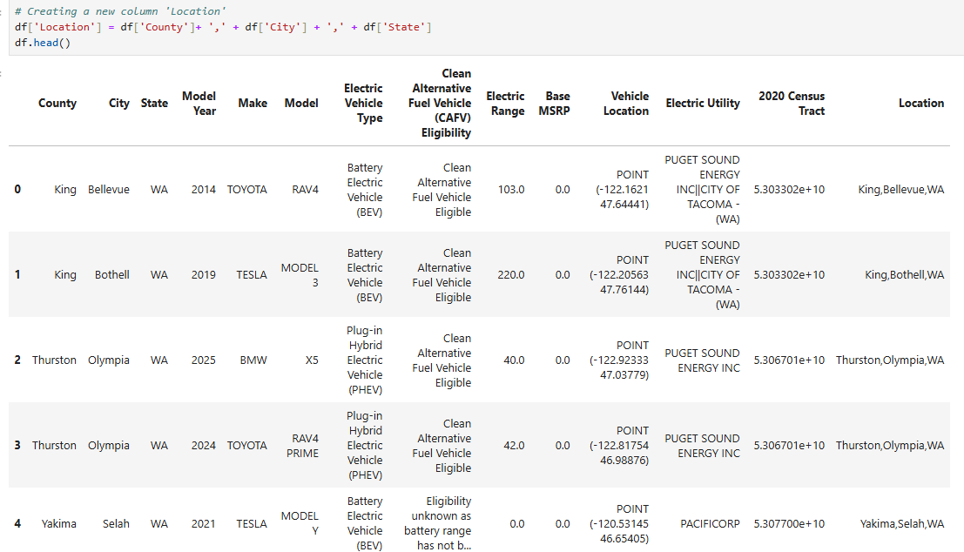

1. Exploratory data analysis **📊**

**📌** How many electric vehicles are produced in each location?

*# Get the value counts for the Location column*

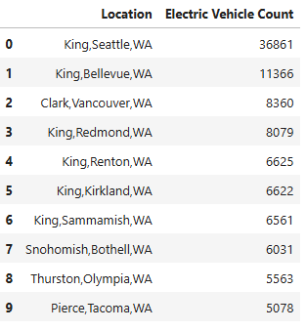

*# Create the bar chart*

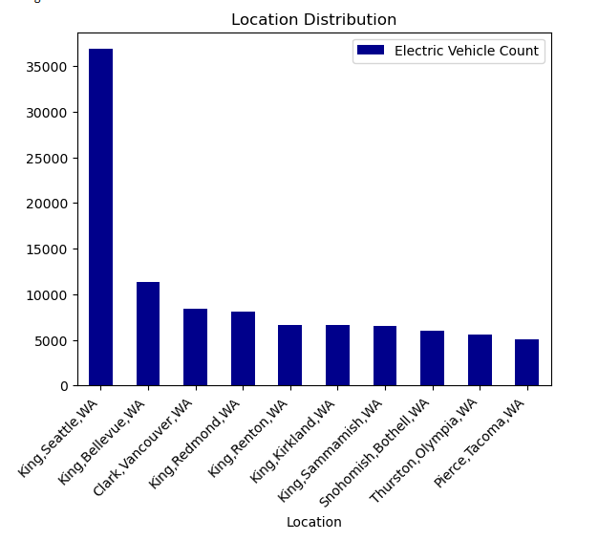

* The highest number of electric cars are located in King County, with Seattle having 36,861 cars, followed by Bellevue, with a count of 11,366 cars. The gap between first place and the others is significant, even though they are all located in Washington state.

**📌** How many electric vehicles are produced per year?

*# Get the value counts for each year*

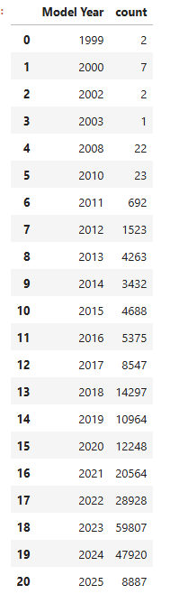

*# Create the bar chart showing the growth along the years*

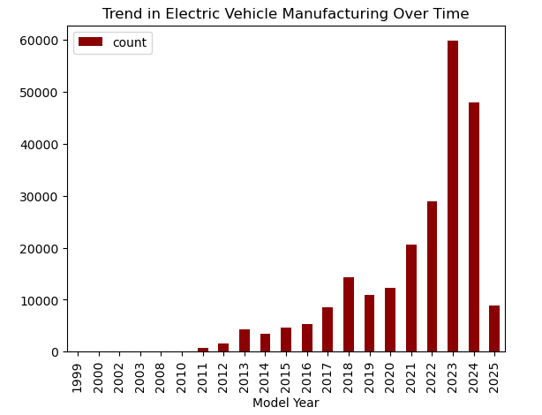

* Between 1999 and 2012 we can say that companies were in a research and test phase.
* The EV market has experienced significant growth and development in recent

years. As the graph shows, 2023 was a big year for the electric cars where the people start to accept this models and become interested in.

**📌** What are the most electric vehicles companies?

*# Get the value counts for top 10 manufacturers*

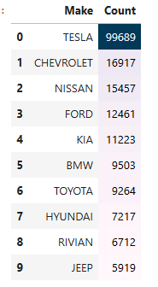

*# Create the bar chart showing the number of cars produced by top 10 companies*

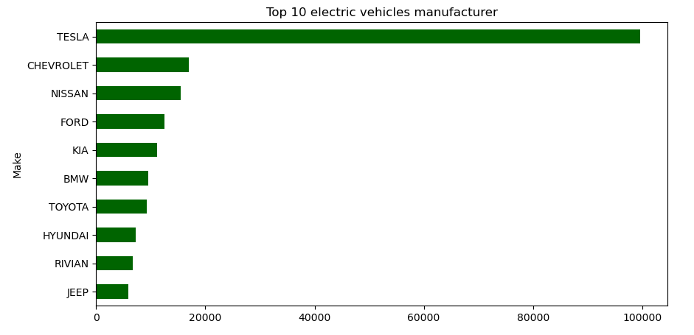

* TESLA is by far the number one company in the electric cars field, with 99,689 cars in

this category. The next most common brands are Chevrolet and Nissan, with 16,917 and 15,457 cars.

**📌** What are the most electric vehicles models produced?

*#* *Get the value counts for top 10 models*

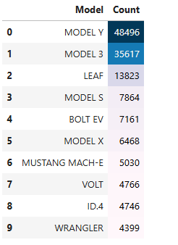

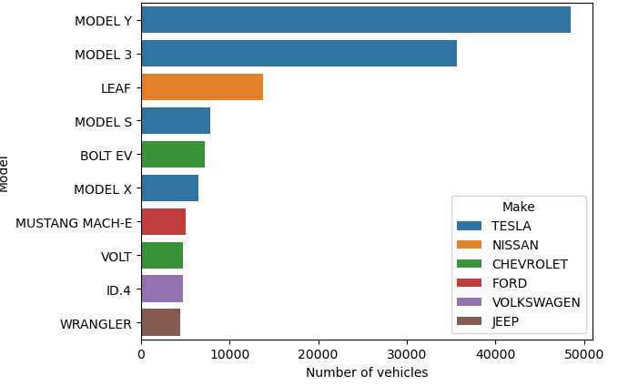*# Create a bar chart showing Top 10 Most Popular Models*

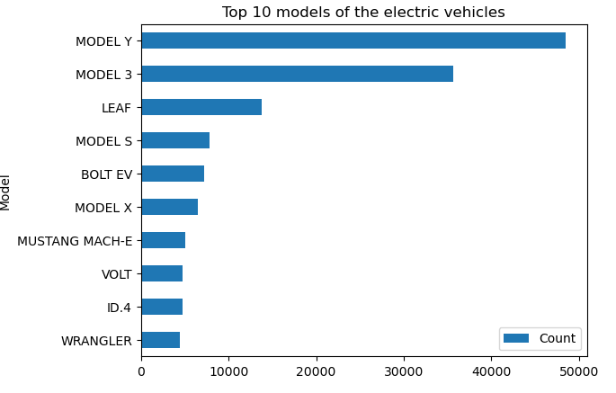

* Tesla dominates the market - MODEL Y (48,496) and MODEL 3 (35,617) are the top two most popular electric vehicles. MODEL S (7,864) and MODEL X (6,468) also appear in the top 10.
* Nissan LEAF holds the third position, showing its popularity in the EV market.

**📌** How many vehicles are produced of each type?

*# Create a pie chart showing the percentage of each type*

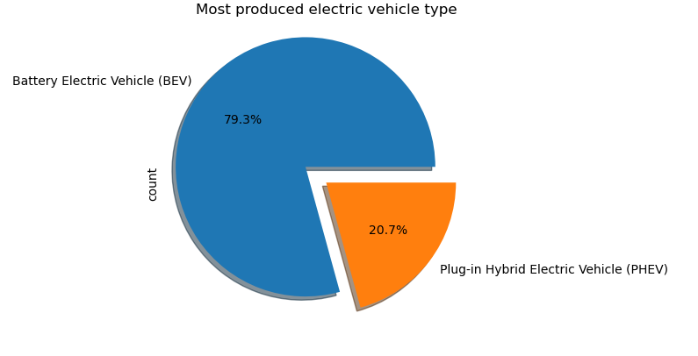

* The Battery Electric Vehicles (BEVs) dominate the dataset with 184,048 cars.
* The next most common type is plug-in hybrid electric vehicles (PHEVs) with 48,144 cars. While still relevant, PHEVs represent a much smaller share of the dataset.

**📌** What are the rates of Eligibility (CAFV)?

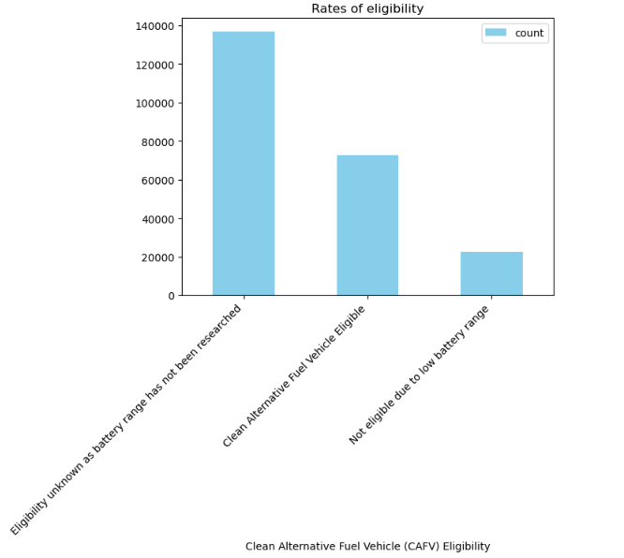

* 136,861 vehicles fall into the "Eligibility Unknown" category. This could indicate

missing data or a lack of clear classification for these vehicles.

* 72,818 vehicles qualify as Clean Alternative Fuel Vehicles (CAFV)
* 22,513 vehicles are not eligible due to low battery range.

**📌** What are the most Electric Utility Companies?

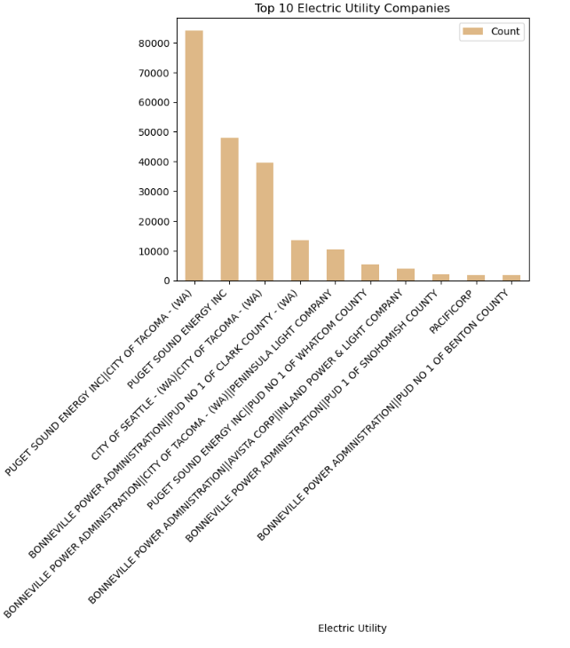

* Puget Sound Energy (PSE) is the leading electric utility provider for EVs in the dataset.
* 84,157 vehicles are served by Puget Sound Energy Inc & City of Tacoma (WA).
* 48,061 vehicles are directly under Puget Sound Energy Inc.
* City of Seattle and Tacoma Are Significant - 39,490 vehicles are connected there, making it another major service provider.
* Bonneville Power Administration (BPA) is involved in multiple partnerships, including: Clark County (13,562 vehicles), Tacoma & Peninsula Light (10,529 vehicles), Avista & Inland Power (3,963 vehicles). The presence of BPAs across different regions suggests a broad regional support for EV infrastructure.

**📌** Distribution of Electric Range

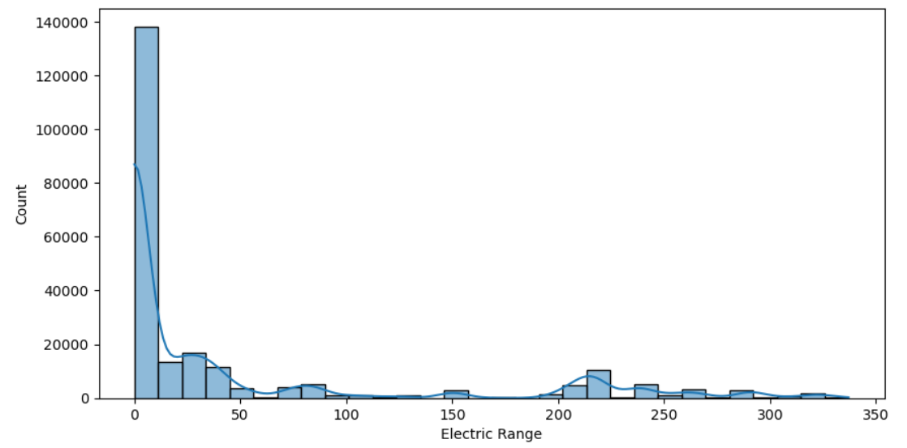

* Over 130,000 vehicles in the dataset have an electric range close to 0 miles. This suggests that the information about battery range has not researched for this lapse, as we can observe previous at eligibility rate.
* Most vehicles are concentrated under 50 miles of electric range. This suggests that many of them are plug-in hybrids (PHEVs), which have a reduced electric range.
* There are only a small number of cars with a range of over 200 miles, indicating a dominance of vehicles with low range in the dataset. Manufacturers may need to focus on improving battery range.
* Very few vehicles exceed 300 miles of range. This shows that long-range models are rare in the dataset.

🔍 **KEY FINDINGS**:

* The majority of electric cars count in the dataset are primarily located in the state of Washington (WA).  While King and Clark counties have the highest number of electric cars, there is still potential to expand the use of electric cars in other counties in the state of Washington.
* 2023 was a big year for the electric cars with companies investing heavily in them and people starting to really understand that electric cars are good for the planet.
* Tesla remains the industry leader in EV market, suggesting high demand for its vehicles. Other manufacturers should analyze Tesla’s success (range, charging network, brand loyalty) to improve their market share.
* There is a significant number of vehicles with "Eligibility unknown as battery range has not been researched." To improve the understanding of the electric vehicle market, it is essential to collect and analyze data on battery range for all electric vehicles.
* BEVs' dominance indicates that consumers and manufacturers are prioritizing fully electric cars over hybrids.
* Puget Sound Energy & Seattle-Tacoma areas are key hubs for electric vehicles with stronger charging infrastructure.
* Future trends could be influenced by charging infrastructure expansion or battery technology advancements.